THE CHALLENGE
St. Cyril Academy Alumnae Association, Danville, PA 17821-1699 Fall 2018

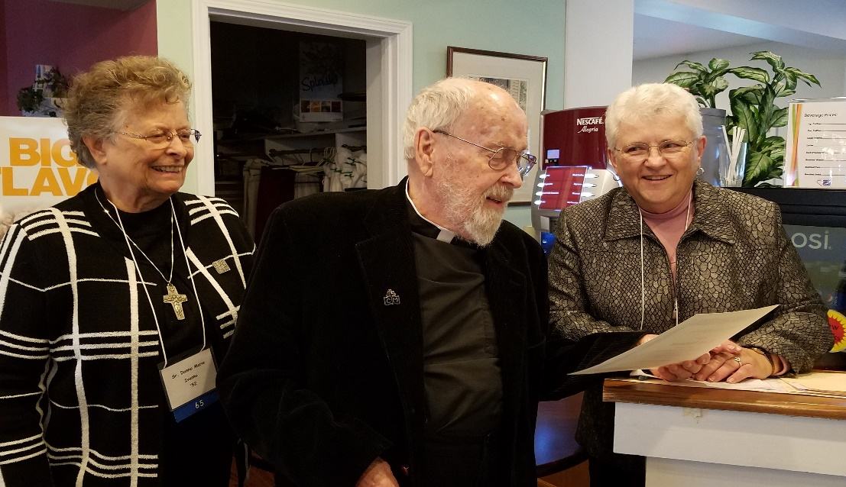
Rev. Gerard Heintzelman receives service certificate of appreciation from Moderator Sr. Donna Marie Ivanko and
Treasurer Joanne Stahura. Many of you remember Fr. Gerry as our former chaplain. He is now the Rector of
the Basilica of Saints Cyril and Methodius.

FROM THE MODERATOR
Dear Alums,
Homecoming! What a glorious day! I was thrilled to see so many of you from way back when, and some from not too long ago. The new schedule made visiting much easier; the banquet was delicious and the décor beautiful. Please come back again soon.
As we (preschool, kindergarten, parents and families—approximately 200 in all) enjoyed our Thanksgiving feast at the Pine Barn Inn on 14 November, I thought of all of you and prayed that your holiday would be filled with joy as you celebrated with family and friends.
My greetings for Christmas travel to you across the miles! You remain in my prayers as I wish you continued success in your many endeavors, living by our motto: “Leave to Serve.”
Sister Donna Marie Ivanko, SSCM (’52)
Moderator

FROM THE EDITOR
Dear Friends,
It was just as I expected. Homecoming was a blast! There were 130 attendees, including guests, with the Jubilee classes well represented. The new schedule was favorably received. Alumnae traveled from far and near to share news and a few laughs about old times. All of the officers worked hard to assure an atmosphere of welcome and belonging. To those who were able to share the joy of the day, thanks for coming! For those who could not make the trip, we missed you and we probably talked about you (in a good way, of course).
The holidays are a magical time of year. Families willingly undergo expense and discomforts of travel, doing everything possible to be with their loved ones. Dining tables groan under the weight of wonderful treats. Decorations give a festive air to every activity. Cards and letters bring greetings of joy and goodwill as well as news from relatives and friends in far-flung places. The atmosphere is electric with anticipation. We participate in the beauty of the Christmas liturgy. We make an extra effort to be our best selves, even as we resolve to achieve greater things in the New Year. As I look forward to these experiences, I send to all of you my best wishes for a wonderful holiday season filled with love and hope.
Mercy Kowalczyk (’64)
Editor
ALUMNAE NEWS
EMMY Comes Calling: Carol (Valyo) Straub (’60) sends us good news about her brother-in-law, John Cole, who is married to Carol’s youngest sister, Mary Ellen. John has been awarded an EMMY for cinematography for Super Bowl LI (Patriots v. Falcons, 2017).
Bloomsburg Fair Standouts: Sister Donna Marie Ivanko (’52) was awarded Best of Show for her display in the horticulture section. Her “101 Dalmatians” creation included a large Dalmatian fireman holding a firehose and surrounded by smaller Dalmatians. Per rules, this entry was constructed of flower pots. Margaret Stahura (’60) won a First, a Second, and a Third prize for the three watercolors she entered.

MAY THEY REST IN PEACE
Alumnae:
Dorothy (Yuscanic) Mascari (’44)—7 November 2012
Janet (Wintersteen) Shade (’46)—11 July 18
Rita (Heintzelman) Sekulski (’42)—19 September 18, sister of Rev. Gerard Heintzelman
Elaine Marie (Kopecky) Sweeney (’67)—17 November 18, sister of Yvonne (Kopecky) Comito (’64)
Family Members:
Theodore J. Mika, husband of Sonya (Zuzov) Mika (’57)—29 September 17
Albert Michael Johnson, brother of Ida (Johnson) Cherasaro-Neal (’53) and Lucy Johnson (’62)—5 June 18
Sr. Faustina Marie of the Good Shepherd, OP (Martha David), younger sister of Sally David (’71)—29 June 18
John Rentko, brother of Magdalene (Midge) (Rentko) Malshefski (’44)—7 November 18

HOMECOMING WRAP-UP
A new schedule was rolled out this year. The day began with registration followed by breakfast and the business meeting in the refectory. Approximately 30 alumnae responded positively to a questionnaire on the new schedule, the cost of registration, the venues for events, menus, and available time for visiting with schoolmates and friends.
During the business meeting the officers were all re-elected to another term. Treasurer Joanne Stahura (’59) provided the financial report. She noted that invitations for Homecoming were sent to 750 alumnae to which only 230 (31%) responded. The Treasurer reported expenses for the printing and mailing of Homecoming invitations, along with the printing of booklets and badges, gifts for attendees, catering expenses for the meals and reception, and miscellaneous office supplies and expenses. Other expenses included the printing and mailing of The Challenge and maintenance of the website. Income was derived from the Homecoming registration fee, dues, and donations. A check was presented, on behalf of the Association, to Sr. Michael Ann Orlik (’66), General Superior of the Sisters of Saints Cyril and Methodius.
Going forward, The Challenge will be mailed in hard copy only to those who replied to the Homecoming invitation and dues-paying members. Others may view The Challenge on the website. Anyone who wishes to continue receiving the newsletter in hard copy should contact an officer of the Association (contact information on last page).
The Homecoming group photo was taken in the Basilica before a short break, then events moved to the Meadows for a reception and formal dinner. The liturgy for Sunday was celebrated back at the Basilica at 5:00 PM with
Fr. Gerry officiating.

Twenty women attended from the Golden Jubilee classes of 1967-68. The Class of 1944 was represented by Midge (Rentko) Malshefski and Mary (Yenchick) Novotnak. Also present were Mary’s daughters: Mary Ann (Novotnak) Askam (’67) and Barbara (Novotnak) Mosca (’69). Midge and Mary also received awards for the frequency of their attendance at reunions.
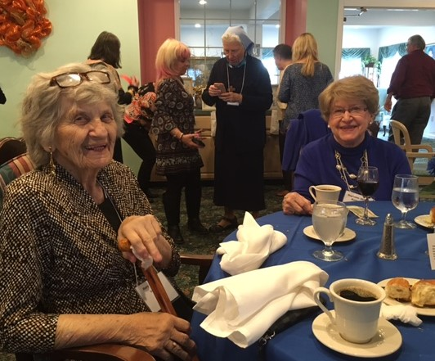
Class of ’44 Homecoming Attendees.
There were other recognitions awarded during the dinner. Jeanne (Charleston) Herbst (’61) got the Early Bird Award as the first to respond to this year’s Homecoming invitation. Unfortunately, Jeanne’s mother was hospitalized with a fractured hip so she had to cancel at the last minute. There were three awards given to those who traveled the farthest: Mary Bolchazy (’62) from Laguna Hills, CA; Yvette Figueroa (’77) from Puebla, Mexico; and Kathleen (Hritz) Briant (’67) from Las Vegas, NV.

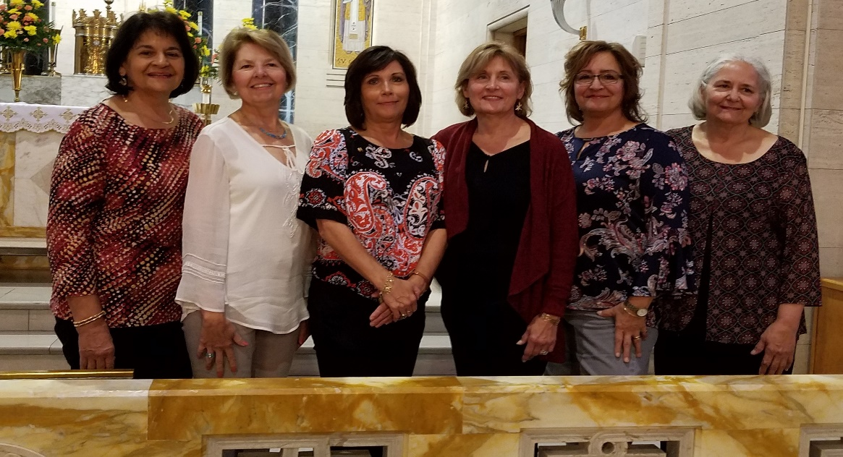
The Vargo Sisters at Homecoming.
The largest group of siblings to graduate from SCA was present and recognized: Sylvia (Vargo) Landis (’66), Joanne (Vargo) Gosh (’68), Gloria (Vargo) Galer (’71), Anna (Vargo) Jeffreys (’74), Judith (Vargo) Molderig (’76), and Bonnie (Vargo) Jaskiewicz (’78).
Margaret Stahura (’60) donated four of her original watercolors depicting four seasons at the Academy. These were raffled off during dinner. The winners were: Spring scene: Margaret (Brady) Hunter (‘76); Summer scene: Grace (Madera) Patalano (’80); Fall scene: Ginette (Decatrel) Breton (’53); and Winter scene: Melissa (Feaster) Keefer (’76).
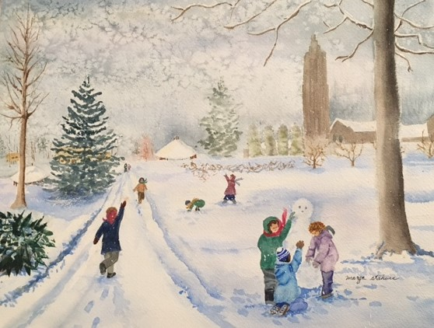
Winter scene watercolor by Marge Stahura.

All of the officers did a wonderful job preparing the many details of Homecoming. Special kudos go to Moderator Sr. Donna Marie Ivanko (’52). Her efforts behind the scenes making placemats, wrapping gifts, arranging the dining room for breakfast and the meeting, ordering flowers, engaging a photographer, and many other details, made Homecoming special for all of us.
You can find more photos of Homecoming activities on the Association website: www.stcyrilacademy.org. Any alumnae who took photos at Homecoming can share them by posting them to the website.

THE WEBSITE
Speaking of the website…since Homecoming a number of people have become new registered users. The site provides access to a lot of password-protected information about the alumnae and our teachers, profiles our geographic dispersal, chronicles alumnae events such as Homecoming, archives The Challenge, and so much more. Go to www.stcyrilacademy.org, the official web address, and sign up today.

MAILING LIST
If you are an alumna living in Danville (or are in contact with anyone who is) we need to hear from you about your new mailing address. Almost two years ago, postal addresses were amended for many Danville residents. The Post Office is no longer forwarding Association mail to these alumnae and are returning mailed items to us as “undeliverable.” We need to hear from you about your amended address so that you can receive notices and other mail from the SCA Alumnae Association.
DUES
If you haven’t already done so, please send your dues to Joanne Stahura. Recall that alumnae religious do not pay dues. As has been the case for many years, annual dues are $10. If you haven’t paid in a while, you are not liable for dues in arrears so start fresh today! As you can see from the news reported in this issue, your dues support a broad spectrum of alumnae activities. Please stay on the mailing list by paying your dues.

SUBMITTING NEWS
Please submit your items to Mercy Kowalczyk. Include your full name (and your maiden name, if you are married), along with your class, mailing address, phone, and e-mail (so we can contact you if there is a need for additional information or clarification).
If you are reporting a death, please give the full name of the individual, their connection to you and/or other alumnae, the date of death, and any other salient information. We are interested in the births of children and grandchildren, as well as educational and other major achievements. If you have received an award, please let us know the name of the award, the reason you received it, and where and when you received it.
If you travel, we’d like to hear about your adventures.

FAREWELL (to too many)!
It is my pleasure to serve as your newsletter editor and, as a writer, it gives me a boost to publish your news items and keep you in the loop on the activities of our school and of our classmates and friends.
You will recall, in the Summer issue, my plea for payment of dues as they support, among other things, the printing and distribution of The Challenge. For most of you, that message apparently went directly to the “dead-letter office.”
This is the last issue that will be sent to all in hard copy. We are faced with the unhappy task of cutting down the mailing list and, beginning with the first issue of 2019, The Challenge will go in hard copy only to those who responded to the Homecoming invitation and those who have paid dues.
The Challenge is an activity that should at least pay for itself. It’s not. Faced with about $3500 expense for four quarterly issues, when offsetting dues total about $1300 a year, means that we will be saying goodbye to most of you after this issue. Lack of financing may eventually necessitate publishing fewer issues per year. No gifts have been received that are sufficient to support even one issue of The Challenge.
I, for one, will really miss you. The thing about writers (aside from being mildly addicted to the smell of ink and the feel of paper) is that they need an audience. Otherwise, there is nothing to share. No feedback to aide improvement. No flow of new ideas. Nothing to say.
Please examine your budget and, if you can manage it, send in your dues and stay on the mailing list. Of course, if you are comfortable in an electronic environment, you will still find The Challenge on the Association’s website.

CONTACT INFORMATION FOR THE 2018-2020 EXECUTIVE BOARD
President: Mary Teresa Berrettini-Molino (’74), 745 Arthur Street, Hazle Township, PA 18201
570.578.7505 coco.74530@yahoo.com
Treasurer: Joanne Stahura (59), 1504 Poolside Drive, Hazle Township, PA 18201
570.436.1839 joannestahura1@verizon.net
Secretary: Vacant due to the recent death of Elaine (Kopecky) Sweeney (’67)
Alumnae Moderator: Sister Donna Marie Ivanko, SSCM (’52)
Villa Sacred Heart, 1002 Railroad Street, Danville, PA 17821
570.275.3581 donnascasscm@hotmail.com

Newsletter Editor: Mercy Kowalczyk (’64), 441 Twin Streams Drive, Warminster, PA 18974
215.880.2972 mercykowal@aol.com

